Water
Equation of the Best-Fit Line: y = 1.3938x + -0.0519
Correlation Coefficient (r): 0.9877
R-squared (R²): 0.9756

$$\tan{θ_{i}}$$ | $$\tan{θ_{r}}$$ | $$\sin{θ_{i}}$$ | $$\sin{θ_{r}}$$
0.1318 | 0.1334 | 0.1307 | 0.1322
0.4386 | 0.4824 | 0.4017 | 0.4345
0.4425 | 0.6857 | 0.4046 | 0.5655
0.6600 | 1.1250 | 0.5508 | 0.7474
1.0667 | 3.1000 | 0.7295 | 0.9517

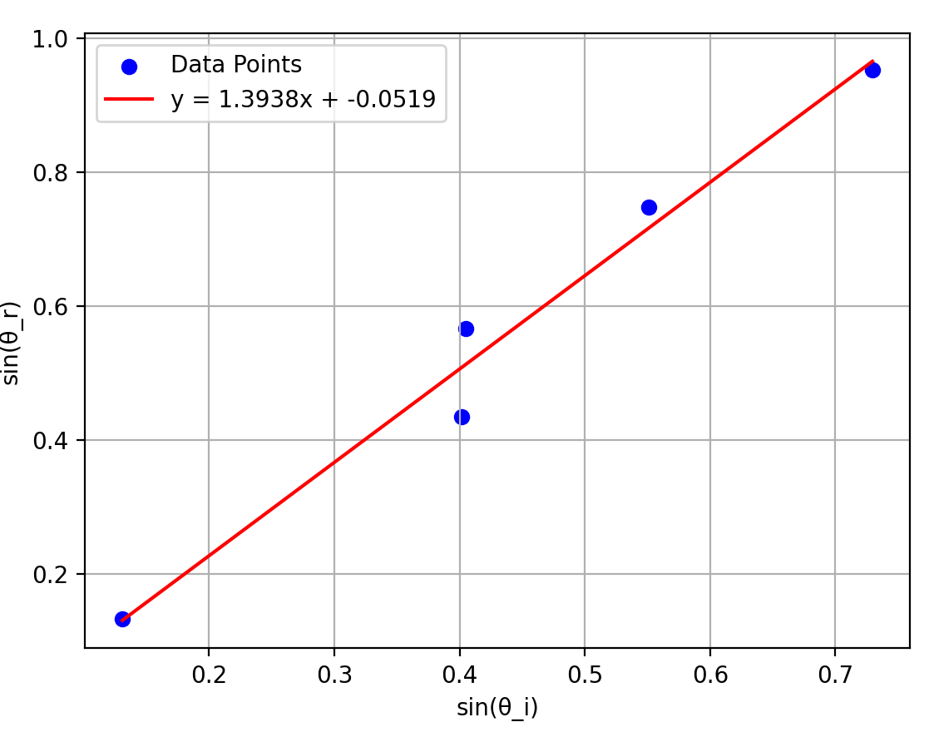

Acrylic

$$\tan{θ_{i}}$$ | $$\tan{θ_{r}}$$ | $$\sin{θ_{i}}$$ | $$\sin{θ_{r}}$$
0.5867 | 0.2963 | 0.5060 | 0.2841
0.9091 | 0.6000 | 0.6727 | 0.5145
2.0800 | 0.8000 | 0.9013 | 0.6247
0.8667 | 0.6000 | 0.6549 | 0.5145
0.4933 | 0.2800 | 0.4424 | 0.2696

Equation of the Best-Fit Line: y = 1.0798x + 0.1588
Correlation Coefficient (r): 0.9531
R-squared (R²): 0.9084

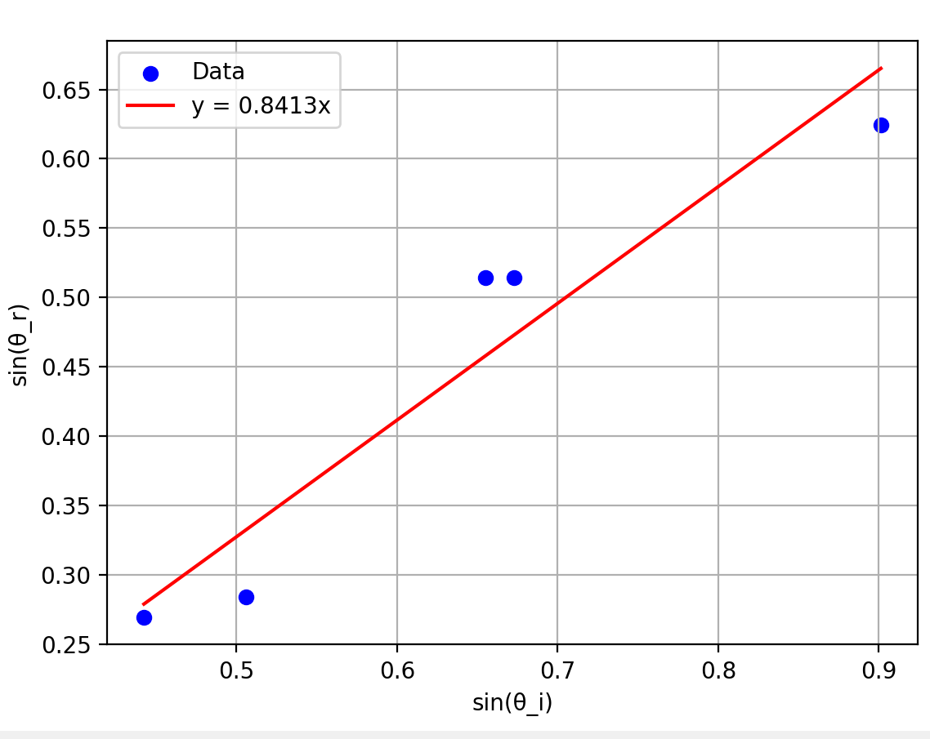

The best fit line with b=0 is y = 1.4064x

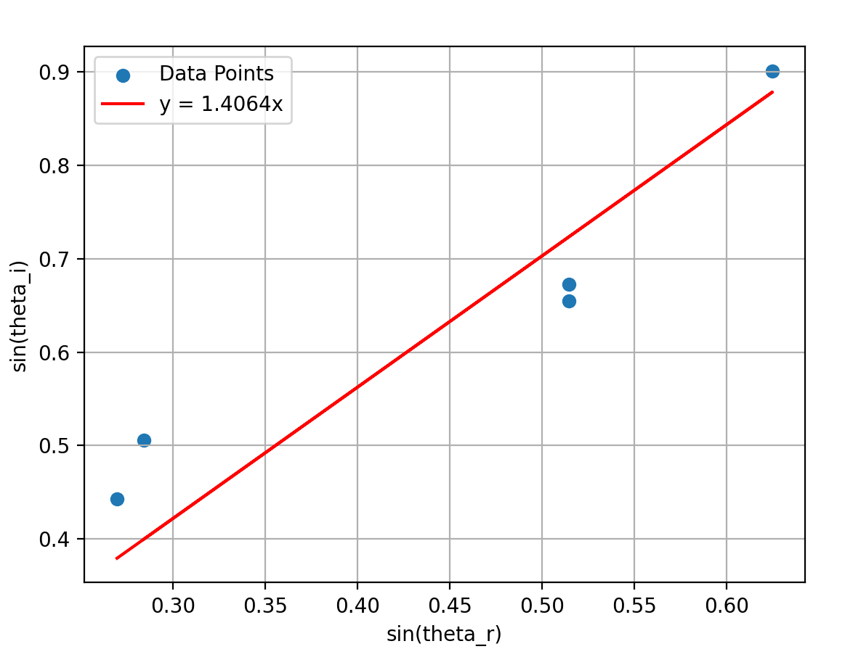

凹透鏡
$$p (cm)$$ | 25.4 | 25.5 | 25.3 | 25.4 | 25.4

P 即焦距

凸透鏡
$$p$$ | $$q$$ | $$1/p$$ | $$-1/q$$
46.4 | 50.2 | 0.02155 | 0.01992
57.3 | 41.5 | 0.01745 | 0.02410
43.8 | 55 | 0.02283 | 0.01818
40.5 | 60 | 0.02469 | 0.01667
60 | 40.5 | 0.01667 | 0.02469

Equation of the Best-Fit Line (No Intercept): y = 1.0265x
Correlation Coefficient (r): 0.9987
R-squared (R²): 0.9973

